**18. Design TM using simulator to accept the input string “ww”**

**AIM:** To design TM using simulator to accept the input string ww **TRANSITION DIAGRAM:**

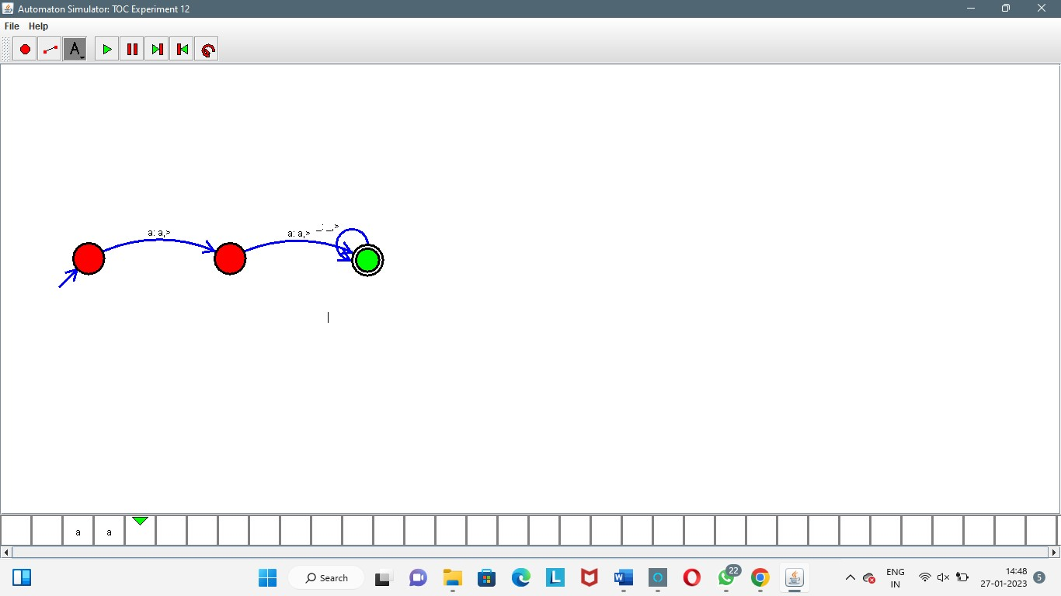

**RESULT:** The TM is designed to compute the string given as input using a simulator.